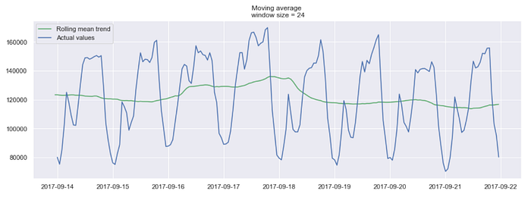 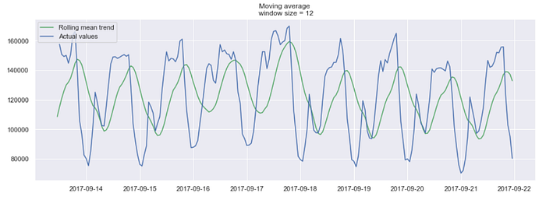



**Exponential smoothing**

Exponential smoothing uses a similar logic to moving average, but this time, a different *decreasing weight*is assigned to each observations. In other words, *less importance*is given to observations as we move further from the present.

Mathematically, exponential smoothing is expressed as:

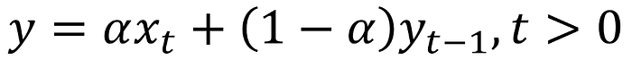

Exponential smoothing expression

Here, *alpha*is a **smoothing factor**that takes values between 0 and 1. It determines how *fast* the weight decreases for previous observations 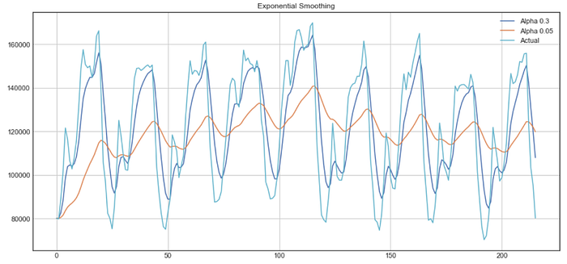

**Double exponential smoothing**

Double exponential smoothing is used when there is a trend in the time series. In that case, we use this technique, which is simply a recursive use of exponential smoothing twice.

Mathematically:

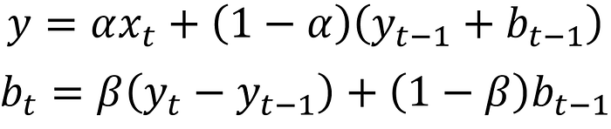



Double exponential smoothing expression

Here, *beta* is the **trend smoothing factor**, and it takes values between 0 and 1.

Below, you can see how different values of *alpha*and *beta*affect the shape of the time series.

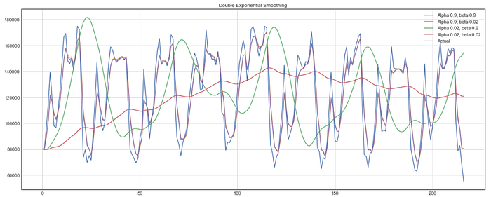

Example of double exponential smoothing

**Tripe exponential smoothing**

This method extends double exponential smoothing, by adding a **seasonal smoothing factor**. Of course, this is useful if you notice seasonality in your time series.

Mathematically, triple exponential smoothing is expressed as:

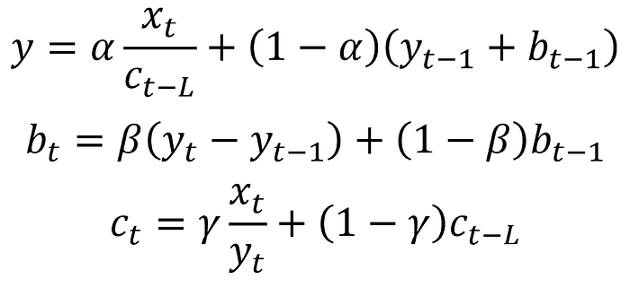



Triple exponential smoothing expression

Where *gamma*is the seasonal smoothing factor and *L*is the length of the season.